SOUTH FORSYTH 2020-2021 INVITATIONAL
WATER QUALITY TEST KEY

Multiple Choice: Choose the most appropriate answer for each question below. Each question
will be worth one point. (30)
- Which of the following statements about the phosphorus cycling is correct?
  - Phosphates move slowly through plants and animals.
  - There are four major processes in the phosphorus cycle.
  - Soil phosphorus can never be buried in lake sediments.
  - Phytoplankton in the ocean does not assimilate orthophosphate.
  - All of the above
  - None of the above
- Which of the following statements about salt marshes is correct?
  - There is no mud in salt marshes.
  - Peat, which is found in salt marshes, is known to have high oxygen levels.
  - Salt marshes are not productive ecosystems.
  - There are two main regions of salt marshes: high marsh and low marsh.
  - All of the above
  - None of the above
- Which of the pairs of constituent and unit processes correctly match each other?
  - Major dissolved inorganics - adsorption
  - Minor dissolved inorganics - coagulation
  - Pathogens - flocculation
  - Turbidity - granular filtration
  - All of the above
  - None of the above
- Which of the following statements about intertidal zones is correct?
  - These areas are exposed to air during high tide and covered up by saltwater during low tide.
  - The spray zone is submerged at high tide but remains dry for long periods of time between high tides.
  - The high intertidal zone is a damp area that is usually only reached by ocean.
  - The low intertidal zone is submerged nearly all the time except during the lowest tides
  - All of the above
  - None of the above
- What is the acronym for the regions of the world’s oceans encompassing coastal areas from river basins and estuaries to the seaward boundaries of continental shelves and the outer margins of the major ocean current system?
- ACEs
- LCEs
- LMEs
- DEEs
- All the above
- None of the above
- Which of the following statements about lagoons is correct?
  - There is only one type of lagoon: coastal lagoons.
  - An atoll lagoon is a body of water that is separated from the ocean by a physical barrier.
  - Atoll lagoons are usually deeper than coastal lagoons.
  - There are lagoons in Antarctica.
  - All of the above
  - None of the above
- Which of the following statements about marine habitats is correct?
  - Marine habitats can be divided into coastal and open ocean habitats.
  - Coastal habitats are found in the area that extends from the shoreline to the continental shelf edge.
  - Open ocean habitats are also found in deep ocean beyond the continental shelf.
  - Pelagic habitats are found near the surface or in the open water column
  - All of the above
  - None of the above
- Which of the following statements about intertidal zones are correct?
  - These areas are farthest to the shore.
  - There are never exposed by tides.
  - This region can never be underwater.
  - Organisms in the intertidal zones bores and grinds exposed rock through bioerosion.
  - All of the above
  - None of the above
- What is the main primary producer at the bottom of the marine food chain?
  - Phytoplankton
  - Zooplankton
  - Predatory zooplankton
  - Filter feeders
  - All of the above
  - None of the above
- Which of the following regions has the highest biomass productivity?
  - Algal beds
  - Open ocean
  - Coral reefs
  - Swamps and marshes
  - All of the above
  - None of the above
- What process in the hydrologic cycle involves precipitation that is intercepted by plant foliage that eventually evaporates back into the atmosphere?
- Infiltration
- Subsurface flow
- Canopy interception
- Evaporation
- All of the above
- None of the above
- What is the term for the process that produces elemental sulfur with an oxidation state of zero?
- Assimilative sulfate reduction
- Desulfurization
- Oxidation of hydrogen sulfide
- Oxidation in elemental sulfur
- All of the above
- None of the above
- Which of the following reservoirs has the highest average residence time?
  - Deep groundwater
  - Antarctica
  - Seasonal snow cover
  - Glaciers
  - All of the above
  - None of the above
- Which of the following is involved in the carbon cycle?
  - Biosphere
  - Pedosphere
  - Geosphere
  - Hydrosphere
  - All of the above
  - None of the above
- Which of the following statements about mangroves is correct?
  - Mangroves are not found in subtropical latitudes.
  - Mangrove ecosystems are very productive and connects the land and sea.
  - The water near mangrove ecosystems is rich in oxygen.
  - The global mangrove carbon storage is 68 million metric tons per year.
  - All of the above
  - None of the above
- What organism is usually found in the second level of the marine food chain?
  - Small crustaceans
  - Copepods
  - Krill
  - Lobster larvae
  - All of the above
  - None of the above
- Which of the following statements about the carbon cycle is correct?
  - Carbon in the atmosphere only exists in the form of carbon dioxide.
  - Photosynthesis is the main process that returns carbon dioxide into the atmosphere.
  - The carbon cycle will most likely increase the rate of carbon dioxide absorption by the soil from the carbonate-silicate cycle in the future.
  - Carbon dioxide cannot dissolve in lakes.
  - All of the above
  - None of the above
- Which of the following statements about the role of the ocean in the carbon cycle is correct?
  - The DIC in the surface layer is exchanged rapidly with the atmosphere.
  - The DIC in the surface layer is 30% higher than the deep layer.
  - Oceans are acidic because of carbon dioxide dissolving into the ocean.
  - The increase of ocean acidity increases the biological precipitation of calcium carbonates.
  - All of the above
  - None of the above
- Which of the following nutrients is cycled by microbes in the ocean?
  - Carbon
  - Nitrogen
  - Phosphorus
  - Trace elements
  - All of the above
  - None of the above
- Which of the following statements about the marine sulfur cycle is correct?
  - The modern global oceans have a sulfur storage of 2.6 x 10²¹ g.
  - The overall input flux is 1.0 x 10¹⁴ g/year with the sulfur isotope composition of ~3‰.
  - There is one major output of sulfur from the oceans.
  - The residence time of sulfur in modern global oceans is 20,000,000 years.
  - All of the above
  - None of the above
- Which of the following statements about the hydrologic cycle is correct?
  - Evapotranspiration is the process when water transpires from ice and evaporates.
  - Ice caps can only store frozen water for 500 years.
  - Buoyancy drives humid air lower.
  - As altitude increases, air pressure increases and temperature increases.
  - All of the above
  - None of the above
- What is the percent composition of nitrogen in the atmosphere?
  - < 1%
  - 40
  - 78%
  - 99%
  - All of the above
  - None of the above
- What is intraspecific competition?
  - Competition between members of the same species.
  - Competition between members of different species.
  - Evolution of corresponding traits in the predator species when the prey species evolves.
  - Members of one species consume members of other species.
  - All of the above
  - None of the above
- Which of the following is a step in the sulfur cycle?
  - Mineralization of organic sulfur into organic forms.
  - Reduction of hydrogen sulfide to sulfate.
  - Oxidation of sulfate to sulfide.
  - Incorporation of sulfide into inorganic compounds.
  - All of the above
  - None of the above
- Which of the following statements about the marine nitrogen cycle is correct?
  - Nitrogen enters the ocean through precipitation, runoff, or nitrogen gas from the atmosphere.
  - Nitrification can convert ammonium to nitrite and nitrate.
  - Ammonium is believed to be the preferred source of fixed nitrogen for phytoplankton.
  - The nutrients in the ocean are not uniformly distributed.
  - All of the above
  - None of the above
- Which of the statements about water treatment processes is correct?
  - Aeration is used in the removal of dissolved iron when present with small amounts of manganese.
  - Disinfection is used to kill pathogens.
  - Filtration is used to remove particles from the water.
  - Sedimentation is the process used for the separation of solids.
  - All of the above
  - None of the above
- Which of the following is considered a major watershed management issue?
  - Keeping the watershed healthy while simultaneously growing it.
  - Improved water quality while balancing the act of cleaning-up urban wastewater and controlling rural sources of pollution.
  - Conserving heritage and a sense of place.
  - Conserving the natural environment and biodiversity.
  - All of the above
  - None of the above
- Which of the following statements about potable water treatment is correct?
  - According to the WHO, 72% of the world’s population had access to an improved drinking-water source in 2015.
  - Coagulation is not needed in the process of potable water treatment.
  - Flocculation is not needed in the process of potable water treatment.
  - Clarification is needed in the process of potable water treatment.
  - All of the above
  - None of the above
- Which of the following statements about the nitrogen cycle is correct?
  - Most fixation is done by free-living or symbiotic bacteria known as diazotrophs.
  - About 30% of the total fixed nitrogen is produced by the Haber-Bosch process.
  - In the process of assimilation, plants absorb nitrate or ammonium from the soil by their root hairs.
  - Bacteria or fungi convert organic nitrogen into ammonium in the process of ammonification.
  - All of the above
  - None of the above
- Which of the following statements about sedimentation pollution is correct?
  - Only coarse suspended particles cause turbidity in waterways.
  - Decreased light due to particles can impede the growth of aquatic plants.
  - Sessile invertebrates cannot be buried by sediment.
  - Fine particles cannot be transported into coastal zones.
  - All of the above
  - None of the above

Identification: Identify the marine organisms shown below. The common name of the organisms will be accepted. Each organism is worth one point. (6)
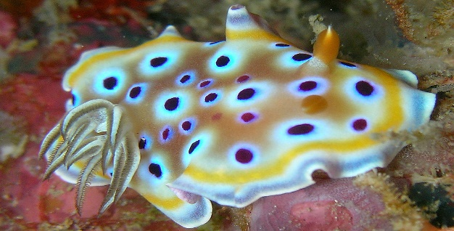
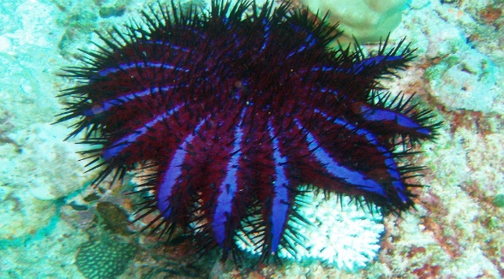
- 34.

Crown-of-Thorns Starfish Sea Slug
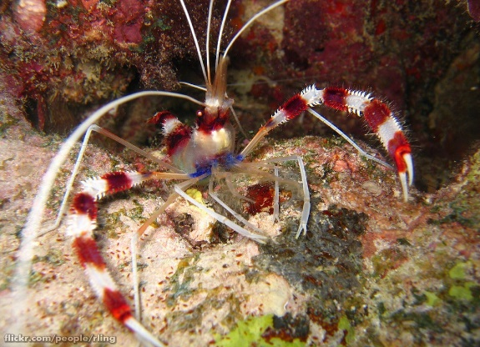
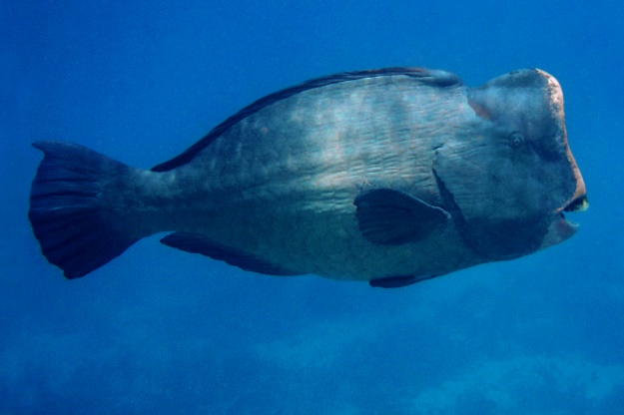
- 35.

Banded Coral Shrimp Parrotfish

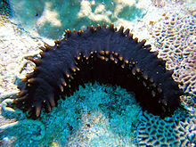
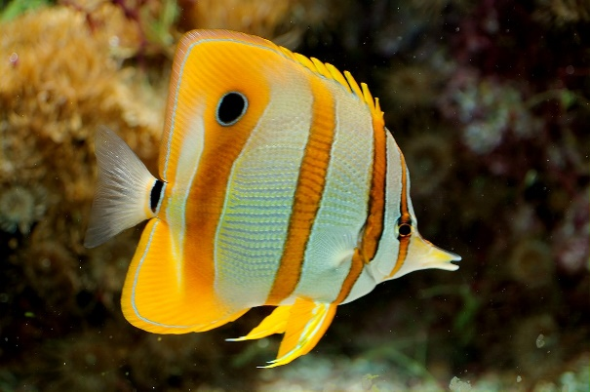
- 36.

Butterflyfish Sea Cucumber

Fill in the blank/Definitions: Match the statement to the term you believe to be correct out of the bank below. Each question is worth a point (11).
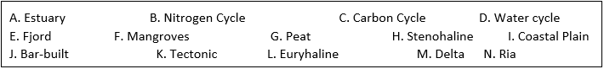
37. ________ Water filtration and habitat protection A. Estuary
38. ________ Barrier beaches or islands parallel to coastline J. Bar-built
39. ________ Tolerates a limited range of salinity H. Stenohaline
40. ________ Glacier created flooded, steep-walled river valleys E. Fjord
41. ________ Tolerates a large range of salinity L. Euryhaline
42. ________ Stabilize shorelines and protect coastal areas from floods and hurricanes I. Coastal Plain
43. _________ Tectonic plates formed K. Tectonic
44. _________ Utilize propagation F. Mangroves
45. ________ Drowned river valley N. Ria
46. ________ Flat, fan-shaped sediment deposits M. Delta
47. ________ Spongy matrix of live roots, decaying organic matter, and soil G. Peat

***FOR THE TOURNAMENT DIRECTORS: WE ARE AWARE MATCHING IS NOT ALLOWED, BUT THE BANK IS AN IMAGE. PLEASE ATTACH THE IMAGE TO EACH QUESTION IF POSSIBLE***

True or False: Label each statement as either true or false. Each question is worth one point. (11)
48. Human’s activity alters watershed functions. True
49. Algal blooms are more likely to be found at the ocean surface than the ocean bottom. True
50. Intertidal mudflats are most expected to occur at the lowest elevation relative to sea level. False
51. Ultraviolet light is not used to treat wastewater. False
52. Watershed management roles aim to control, enhance, and restore watershed functions. True
53. Eutrophication is NOT a potential consequence of untreated wastewater pollutants. False
54. Estuaries do not filter water and provide nutrients to surrounding ecosystems. False
55. Phosphorus is most commonly found in oceanic sedimentary rock. True
56. The order in which sediment is deposited (settles out of the water) is: Gravel, Silt, Sand, Clay. False
57. Wastewater treatment facilities utilize multiple methods to remove about 90% of suspended solids from wastewater. True
58. Sedimentation pollution is comprised of two components: Physical pollution and Chemical pollution. True

Short Answer: Answer the following questions. Point values are different for each question and have been indicated. These will also function as tie-breakers.
59. Describe one way that overfishing can cause damage to a reef ecosystem. (4)
Possible answers may include:
a. Debris and pollutants left behind by fishing practices can be harmful to reef life outside of the target fish.
b. The target fish could be key in maintaining balance in the ecosystem- herbivores that keep the reef from algae dominance, fish that keep other populations in check, etc. The idea in this response is that the ecological balance of the reef could be thrown off.
c. Removing young fish before they can reproduce keeps their population from replenishing.
d. Removing larger fish likewise removes individuals likely to survive and reproduce, causing populations to dwindle.
60. Describe the difference between point and nonpoint pollution sources. Give an example of each. (3)
Point sources can be traced back to a single point of origin, while nonpoint sources cannot (1). Point sources include power plants, wastewater treatment centers, etc. (1). Nonpoint sources might include farmland, urban areas, etc. (1).
61. Describe the conventional laboratory procedure for determining biochemical oxygen demand. (6)
Take a sample of water, measure the dissolved oxygen level, place it in a sealed bottle, and incubate for 5 days at 20 +/- 1º C in the dark. Determine the oxygen consumption in the water at the end of incubation by measuring the final dissolved oxygen level.
- 1 point for sealing bottle in container
- 1 point for incubating water
- 1 point for correct incubation time of 5 days
- 1 point for stating that incubation occurs in the dark
- 2 points for measuring dissolved oxygen level before AND after (1 point if only measure before or after, 0 points if not measured)

Use the following graph to answer question 62.
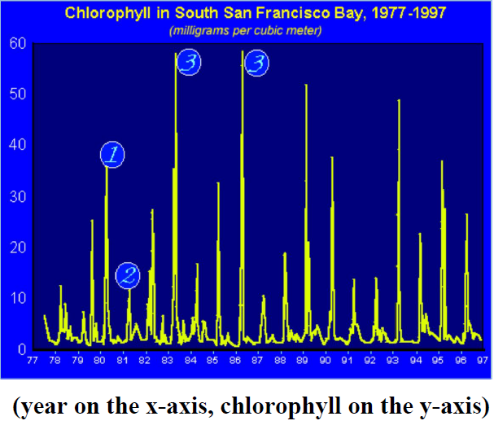
62. What is the most likely cause of the annual spikes on the graph? (2)
Spring Algal Blooms (algal blooms is also acceptable)
Use the following picture to answer question 63.
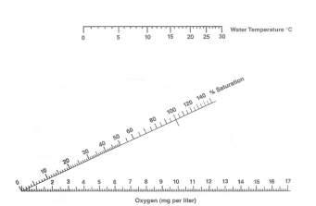
63. A water body has a temperature of 5o C and a dissolved oxygen level of 10 mg/L. Using the saturation chart given above, determine the dissolved oxygen content in percent saturation for the water body. (1)
80%
64. A solution has a pH of 5. The pH is then decreased to 2. By what factor did the concentration of hydrogen ions increase? (1)
1000
Use the following picture to answer question 65.
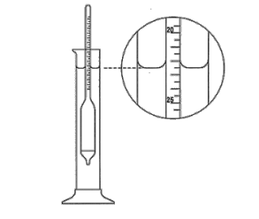
65. The hydrometer shown above is measuring the salt concentration of the solution within the graduated cylinder. What is the reading on the hydrometer? (1)
22.5%
66. Explain why fecal coliform bacteria is used as an indicator of poor water quality. (1)
The presence of fecal coliform bacteria is an indicator of sewage bacteria (1 point for mentioning “sewage bacteria”)
67. Name two reasons why people would be interest in sampling water for its quality. (2)
Check for pollution (1)
Aquatic animal health (1)
68. Alkalinity is the result of three negatively charged ions which shift pH to the alkaline side of neutrality. Name these three charged ions. (Actual name not formula) (3)
Bicarbonate (1)
Carbonate (1)
Hydroxide (1)
69. Name two nutrients needed for plant and animal growth that are fundamental elements in metabolic reactions (2).
Nitrogen (1)
Phosphorus (1)
70. What pH number indicates that a substance is neutral? (1)
7

